Lignans

The lignans are a large group of low molecular weight polyphenols found in plants, particularly seeds, whole grains, and vegetables. The name derives from the Latin word for "wood". Lignans are precursors to phytoestrogens. They may play a role as antifeedants in the defense of seeds and plants against herbivores.
Lignans are a subgroup of non-flavonoid polyphenols.
They are widely distributed in the plant kingdom, being present in more than 55 plant families, where they act as antioxidants and defense molecules against pathogenic fungi and bacteria.
In humans, epidemiological and physiological studies have shown that they can exert positive effects in the prevention of lifestyle-related diseases, such as type II diabetes and cancer. For example, an increased dietary intake of these polyphenols correlates with a reduction in the occurrence of certain types of estrogen-related tumors, such as breast cancer in postmenopausal women.
In addition, some lignans have also aroused pharmacological interest. Examples are:

- podophyllotoxin, obtained from plants of the genus Podophyllum(Berberidaceae family); it is a mitotic toxin whose derivatives have been used as chemotherapeutic agents;
- arctigenin and tracheologin, obtained from tropical climbing plants; they have antiviral properties and have been tested in the search for a drug to treat AIDS .

Chemical structure of lignans
Their basic chemical structure consists of two phenylpropane unitslinked by a C-C bond between the central atoms of the respective side chains (position 8 or β), also called β-β’ bond. 3-3′, 8-O-4′, or 8-3′ bonds are observed less frequently; in these cases the dimers are called neolignans. Hence, their chemical structure is referred to as (C6-C3)₂, and they are included in the phenylpropanoid group, as well as their precursors: the hydroxycinnamic acids (see below).
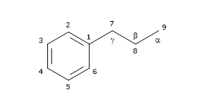Fig. 1 – Phenylpropanoid unit
Based on their carbon skeleton, cyclization pattern, and the way in which oxygen is incorporated in the molecule skeleton, they can be divided into 8 subgroups: furans, furofurans, dibenzylbutanes, dibenzylbutyrolactones, dibenzocyclooctadienes, dibenzylbutyrolactols, aryltetralins and arylnaphthalenes. Furthermore, there is considerable variability regarding the oxidation level of both the propyl side chains and the aromatic rings.
They are not present in the free form in nature, but linked to other molecules, mainly as glycosylated derivatives.
Among the most common lignans, secoisolariciresinol (the most abundant one), lariciresinol, pinoresinol, matairesinol and 7-hydroxymatairesinol are found.
Note: They occur not only as dimers but also as more complex oligomers, such as dilignans and sesquilignans.

Biosynthesis and metabolism
Lignans and lignin differ in their molecular weight, the former being small and soluble in water, the latter being high polymers that are undigestable. Both are polyphenolic substances derived by oxidative coupling of monolignols. Thus, most lignans feature a C₁₈ cores, resulting from the dimerization of C₉ precursors. The coupling of the lignols occurs at C8.

Biosynthesis of lignans
In this section, we will examine the biosynthesis of some of the most common lignans.
The pathway starts from 3 of the 4 most common dietary hydroxycinnamic acids: p-coumaric acid, sinapic acid, and ferulic acid (caffeic acid is not a precursor of this subgroup of polyphenols). Therefore, they arise from the shikimic acid pathway, via phenylalanine.
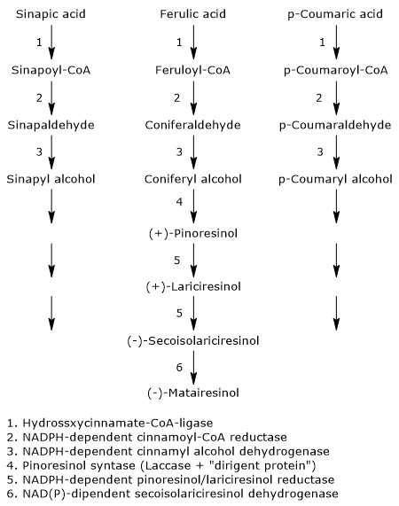Fig. 2 – Lignan Biosynthesis
The first three reactions reduce the carboxylic group of the hydroxycinnamates to alcohol group, with formation of the corresponding alcohols, called monolignols, that is, p-coumaric alcohol, sinapyl alcohol and coniferyl alcohol. These molecules also enter the pathway of lignin biosynthesis.
- The first step, which leads to the activation of the hydroxycinnamic acids, is catalysed by hydroxycinnamate:CoA ligases, commonly called p-coumarate:CoA ligases (EC 6.2.1.12), with formation of the corresponding hydroxycinnamate-CoAs, namely, feruloil-CoA, p- coumaroyl-CoA and sinapil-CoA.
- In the second step, a NADPH-dependent cinnamoyl-CoA: oxidoreductase, also called cinnamoyl-CoA reductase (EC1.2.1.44) catalyzes the formation of the corresponding aldehydes, and the release of coenzyme A.
- In the last step, a NADPH-dependent cinnamyl alcohol dehydrogenase, also called monolignol dehydrogenase (EC 1.1.1.195), catalyzes the reduction of the aldehyde group to an alcohol group, with the formation of the aforementioned monolignols.
The next step, the dimerization of monolignols, involves the intervention of stereoselective mechanisms, or, more precisely, enantioselective mechanisms.In fact, most of the plant lignans exists as (+)- or (-)-enantiomers, that is, isomers with property of chirality, whose relative amounts can vary from species to species, but also in different organs on the same plant, depending on the type of reactions involved.
The dimerization can occur through enzymatic reactions involving laccases (EC 1.10.3.2). These enzymes catalyze the formation of radicals that, dimerizing, form a racemic mixture. However, this does not explain how the racemic mixtures found in plants are formed. The most accepted mechanism to explain the stereospecific synthesis involves the action of the laccase and of a protein able to direct the synthesis toward one or the other of the two enantiomeric forms: the dirigent protein. The reaction scheme might be: the enzyme catalyzes the synthesis of phenylpropanoid radicals that are orientated in such a way to obtain the desired stereospecific coupling by the dirigent protein.
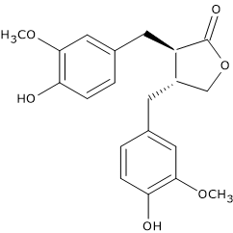
Fig. 3 – (-)-Matairesinol
For example, pinoresinol synthase, consisting of laccase and dirigent protein, catalyzes the stereospecific synthesis of (+)-pinoresinol from two units of coniferyl alcohol. (+)-Pinoresinol, in two consecutive stereospecific reactions catalyzed by NADPH-dependent pinoresinol/lariciresinol reductase (EC 1.23.1.2), is first reduced to (+)-lariciresinol, and then to (-)-secoisolariciresinol. (-)-Secoisolariciresinol, in the reaction catalyzed by NAD(P)-dependent secoisolariciresinol dehydrogenase (EC 1.1.1.331) is oxidized to (-)-matairesinol.
Food sources
The richest dietary source is flaxseed (linseed), that contains mainly secoisolariciresinol, but also lariciresinol, pinoresinol and matairesinol in good quantity (for a total amount of more than 3.7 mg/100 g dry weight). They are also found in sesame seeds.
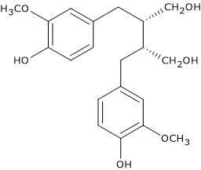Fig. 4 – (-)-Secoisolariciresinol
Another important source is whole grains.
They are also present in other foods, but in concentrations from one hundred to one thousand times lower than those of flaxseed. Examples are:
- beverages, generally more abundant in red wine, followed in descending order by black tea , soy milk and coffee;
- fruits, such as apricots, pears, peaches, strawberries;
- among vegetables, Brassicaceae, garlic, asparagus and carrots;
- lentils and beans.
Their presence in grains and, to a lesser extent in red wine and fruit, makes them, the main source of phytoestrogens.

Lignans (C6-C3-C3-C6) are dimers of phenylpropane ((C6-C3)2) derivatives, combined with C-C linkages between middle carbon atoms of side chains. Lignans are spread in Araliaceae, Berberidaceae, Pinaceae, Schizandraceae, being the constituents of resin exudate trees and bushes. Lignans are soluble in fixed and volatile oils, resins.
Lignans and neolignans are typically found as dimeric phenylpropanoid derivatives chemically related to the polymeric lignins of the plant cell and are found in woody tissues. Neolignans are formed by unsymmetrical carbon-carbon links in the side chains. Lignans and neolignans play an important role in the plant defense as antimicrobial, antifungal, and antifeedant agents. Because they have antitumor and antiviral activity, lignans are of considerable pharmacological interest.
Podophyllotoxin from Podophyllum peltatum, Berberidaceae is an active antitumour drug. Schizandrine, obtained from fruits of Schizandra chinensis, Schizandraceae is stimulating and adaptogenic agent. The same actions, due to syringoresinole, have rhizomes and roots of Eleutheroccocus senticosus, Araliaceae. Flavonoglycans of Silybum marianum, Asteraceae cause hepatoprotective action.
Lignans (C6-C3-C3-C6) are dimers of phenylpropane (C6-C3)2 derivatives, combined with C-C linkages between middle carbon atoms of side chains.

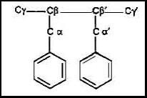

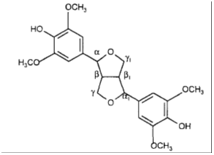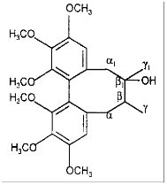

Syringoresinol schizandrine
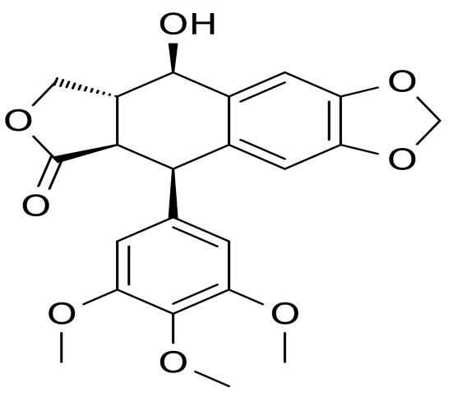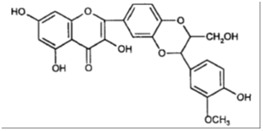
Podophyllotoxin silibin

Lignans are spread in Araliaceae, Berberidaceae, Pinaceae, Schizandraceae, being the constituents of resin exudate trees and bushes.
Lignans and neolignans are typically found as dimeric phenylpropanoid derivatives chemically related to the polymeric lignins of the plant cell and are found in woody tissues. Neolignans are formed by unsymmetrical carbon-carbon links in the side chains.
Norlignans—these are biogenetically close to lignans (and probably specific for gymnosperm types), though structurally resemble neolignans more; they are de facto lignan derivatives with a lower number of carbons (substances of diphenylbutadiene type C6–C4–C6, or conioids C6–C5–C6) and the presence of other, often even conjugate double bonds.
Hybrid lignans—the term refers to their mixed biogenetical origin: they are flavono-lignans (e.g., so called silymarin in Silybum marianum achenes, hydnocarpin in Hydnocarpus wightiana seeds), coumaro-lignans (hyosgerin from Hyoscyamus niger seeds), or xantolignans (kielcorin from Hypericum spp. roots).
Into this group also belong so-called lignoids, e.g., crinasiatin from Crinum asiaticum tubers, representing the first lignophenanthridine alkaloid, or a range of macrocyclical spermine alkaloids, e.g., orantine, hordatine, aphelandrine, etc., in whose molecules neolignan substructures can be found.
An important part is played by furano-furanoid lignans (more precisely dibenzylbutanes), contained in important pharmaceutical and food materials, e.g., seeds of cultivated flax (Linum usitatissimum).
A great reservoir of lignans is constituted by resins of gymnosperm types, containing lariciresinol and pinoresinol, hydroxymatairesinol and substances of sesamine type, and their occurrence is quite common in everyday plant food (cereals, rice, soya, some nuts, seeds, and fruits) and natural beverages (white and red wine).

Classification of lignans
Eight classes of lignans are: "furofuran, furan, dibenzylbutane, dibenzylbutyrolactone, aryltetralin, arylnaphthalene, dibenzocyclooctadiene, and dibenzylbutyrolactol.
Many lignans are metabolized by mammalian gut microflora, producing so-called enterolignans.
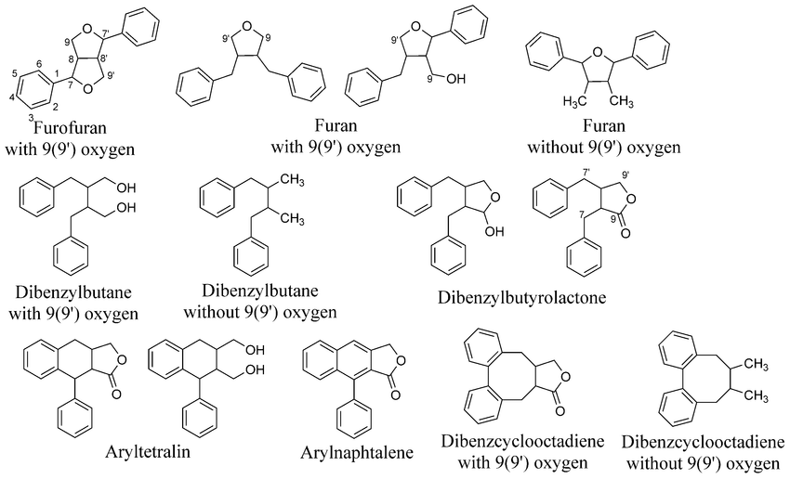

Physicochemical properties
Lignans are colourless crystallic substances, soluble in fixed and volatile oils, resins, chloroform, benzene, diethylester. They occur in plants as aglycones and glycosides, often dissolved in fixed and volatile oils, resins. Lignans develop yellow or blue fluorescence in UV light.
Extraction of lignans
For lignans extraction ethanol and petroleum ethers, benzene and chloroform are used with further fractionation by column chromatography on silica gel and aluminium oxide. TLC serves usually in the final step for purification of lignans.
Extraction in the Soxhlet extractor is a common, probably the most widely used method; it can be used for sequential extraction (the use of solvents or their mixtures with increasing polarity), which is usually started with petroleum ether, n-hexane, or a halogenated hydrocarbon; this procedure is especially important in the case of seeds or fruits with a high lipid content. After removing lipidic substances, polar solvents (ethanol, methanol, and acetone) are used for preparation of total extracts, often with addition of a certain amount of water. For the extraction of polyphenols inclusive lignans of grains 30% acetone can also be successfully used. Most aglycones have low to medium polarity and must be extracted with relatively nonpolar solvents.
Purification of total extracts with lignan content is quite time-consuming and laborious; it is though suitable to carry it out because in following TLC it makes analysis significantly easier. Methanol extracts are usually concentrated, diluted with water, this suspension fractioned with n-hexane and consequently with chloroform, dichloromethane, or ethyl acetate with the aim to obtain a lignan fraction.
Detection
Lignans may be characterized by reactions for phenolics: with ferric salts, dinitroreagents, alkali and other. Very usable is copulation reaction of phenolic hydroxyl group with diazotized compounds. Identification of the predominant lignans is facilitated by specific colours obtained by colouring agents. Spraying with sulphuric acid in ethanol followed by rapid heating gives different colours to lignans: violet, red or red-brown, dark gray, and blue.
As lignans absorb UV light, they are readily detected at 254 nm using the plates with fluorescent indicator. Alternatively, the spots on developed plates can be temporarily visualized by plate exposure to iodine vapor. Some lignans give characteristic blue fluorescent spots under UV light.
Chromatographical analysis
TLC as a simple, inexpensive, and rapid method is applied mostly for a first qualitative examination of plant extracts and for monitoring various stages of lignin purification. It is possible to obtain good results by TLC especially because most lignans are substances of lower or medium polarity and therefore TLC can be successfully used mainly in the form of adsorption chromatography.
Simple mixtures of these substances may be separated by PC in butanol acetic acid - water and 15% acetic acid. More complex mixtures can be separated using butanol - acetic acid - aqueous molybdic acid on chromatography paper previously impregnated with dilute molybdic acid. Complex mixtures may also be resolved by TLC on silica gel using such solvents as ethyl acetate - methanol (19: 1) or benzene - ethanol (9: 1).
Unfortunately, there does not seem to be a specific spray reagent, which distinguishes lignans from other simple phenols. Lignans can be seen as dark absorbing spots on paper in short UV light or can be revealed by spraying with 10% antimony chloride in chloroform. On TLC plates, they are detected by spraying with conc. H2S04. Lignans can be further identified by spectral means; they show absorption at 280 – 284 nm, this band being shifted to about 298 nm in the presence of alkali.
The progress in instrumentation has led HPTLC densitometry to an improvement of its reliability, making this technique competitive with HPLC-UV detection.
Biological activity of lignans
Lignans and neolignans play an important role in the plant defense as antimicrobial, antifungal, and antifeedant agents. Because they have antitumor and antiviral activity, lignans are of considerable pharmacological interest.
Podophyllotoxin from Podophyllum peltatum, Berberidaceae is an active antitumour drug. Schizandrine, obtained from fruits of Schizandra chinensis, Schizandraceae is stimulating and adaptogenic agent. The same actions, due to syringoresinole, have rhizomes and roots of Eleutheroccocus senticosus, Araliaceae. Flavonoglycans of Silybum marianum, Asteraceae cause hepatoprotective action.
Among the lignans of other structural groups, substances of dibenzocyclooctadiene type isolated from Schisandra chinensis seeds are beginning to play an important part. Out of the total of about 50 compounds the main lignans schizandrin, deoxyschisandrin, gomisin are worth mentioning. They exhibit antioxidative, hepatoprotective and neurotrophic activity; the hepatoprotective activity is considered to be the most significant effect. It is based on an increase of glutathione content in tissues and protection against oxidative stress.
Much attention is still attracted by other biologically active types of phenylpropane condensates, flavonolignans from Silybum marianum achenes represented by so-called silymarin complex, namely the mixture of silybins (silybin A), isosilybins, silydianin, and silychristin with an important antioxidative, but especially hepatoprotective activity, and prospective neolignans magnolol and honokiol, contained in Magnolia officinalis bark is an important medicinal drug in Oriental medicine.
Antiinvasive effects (antimicrobial, antifungal, antiviral, antineoplastic) of lignans are important. Lignans of aryltetraline type - podophyllotoxin, 4’-demethylpodophyllotoxin, α-peltatine, β-peltatine from rhizomes and roots of Podophyllum peltatum and their semisynthetic derivatives etoposide and teniposide are employed currently; while the use of podophyllotoxin is limited (external for treatment of condylomas), etoposide and teniposide have become important parts of therapeutic schemes in treatment of some neoplasms.

MPM name | Source | Constituents | Action, use
Rhizomata et Radices Podophylli | Podophyllum peltatum L. (podophyllum), Berberidaceae | 3 to 6% resin (lignans podophyllotoxin (20%), a- and b-peltatins (5 and 10% respectively), desoxypodophyllotoxin, and close derivatives | podophyllotoxin is an active antitumour drug
Semina Silybi | Silybum marianum (L.) Gaertn (St.Mary thistle, blessed milk thistle), Asteraceae. | flavonolignans. (silymarin 1.5 to 3%; silybin, silydianin, silychristin) lipids; proteins; flavonoids | hepatoprotective properties due to flavonolignans
Rhizomata et Radices Eleutherococci | Eleutherococcus senticosus (Rupr. et Maxim.) Maxim.  (Eleutherococcus, Siberian Ginseng), Araliaceae | 8 eleutherosides (lignans, triterpene saponins, coumarins); volatile oil and resins. The main lignan is syringoresinol | CNS stimulant and adaptogenic, decreases sugar level in blood
Fructus Schizandrae, Semen Schizandrae | Schizandra chinensis (Turcz.) Baill., Schizandraceae | lignans (in the seeds 5 to 20%): dibenzo[a,c]cyclooctene derivatives, including schizandrine A to C, schizandrol A and B, schizantherine A and B, gomisins; fatty oil (in the seeds): chief fatty acids oleic acid and linoleic acid; volatile oil. | Schisandra fruits and seeds are believed to bring about a non-specific increase in physical performance ability. Tinctures from bark and seeds are used as the CNS stimulants
Herba Centaurii | Centaurium erythraea Rafn. (C. minus Moench, C. umbellatum Gilib., Erythraea centaurium (L.) Pers.) (centaury), Gentianaceae. | xanthones, substituted in position 6; monoterpenoid glycosides (iridoids gentiopicrine, gentiopicroside, swertiamarine, amarogentine); volatile oil, monoterpenoid alkaloids (gentianine, gentiamine, gentianidine) . | infusion is used as a bitter; herb is a component of appetite and stomach teas

Xantones
Xanthones are secondary metabolites commonly occurring in higher plant families, fungi, and lichen. Their pharmacological properties have raised great interest. Structures of xanthones are related to that of flavonoids and their chromatographic behaviours are also similar. Flavonoids are frequently encountered in nature, whereas xanthones are found in limited number of families. Xanthones always occur in the families Gentianaceae, Guttiferae, Moraceae, Clusiaceae, and Polygalaceae. Xanthones are sometimes found as the parent polyhydroxylated compounds but most are mono- or polymethyl ethers or are found as glycosides. Unlike iridoids, xanthones are apparently not present in all plant species investigated in the family Gentianaceae. This is documented by the systematic work of Hostettmann et al. Natural occurrence of 12 xanthones in higher plants and 4 in fungi has been reviewed by Roberts in 1961 and by Dean in 1963. Gottlieb mentioned the isolation of 60 xanthones from higher plants and 7 from fungi, whereas Carpenter et al. listed 82 xanthones from higher plants. Gunasekera recorded 183 xanthones from 5 families of tracheophyta. According to Vieira and Kijjoa, out of total 515 xanthones, 278 were reported from natural sources. These xanthones have been isolated from 20 families of higher plants (122 species in 44 genera), fungi (19 species), and lichens (3 species). In this period, the xanthones from higher plants appear to be associated mainly with the families Clusiaceae (55 species in 12 genera) and Gentianaceae (28 species in 8 genera). Bo and Liu have reviewed separation methods used for pharmacologically active xanthones. Jose Pedraza-Chaverri et al. reviewed the isolated chemical constituents and medicinal properties of C. Garcinia (mangostana). Some of the plants, ferns, and fungus species which contain xanthones are Artocarpus, Anthocleista, Allanblackia, Andrographis, Aspergillus, Bersama, Blackstonia, Calophyllum, Canscora, Centaurium, Chironia, Cratoxylum, Comastoma, Garcinia, Cudrania, Eustoma, Emericella, Frasera, Garcinia, Gentiana, Gentianella, Gentianopsis, Halenia, Hoppea, Hypericum, Ixanthus, Lomatogonium, Mesua, Morinda, Macrocarpaea, Mangrove fungi, Orphium, Peperomia, Pentadesma, Polygala, Penicillium, Phoma, Phomopsis, Rheedia, Rhus, Securidaca, Symphonia, Schultesia, Swertia, Tripterospermum, Vismia, Veratrilla, and Xylaria.

Xanthones (C6-C1-C6) are organic compounds of plant origin, derivatives of dibenzo-γ-pyrone.
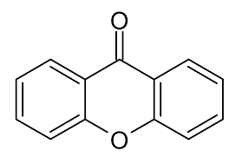
xanthone (dibenzo- g- pyrone)

Xanthones are found in Gentianaceae, Clusiaceae (Hypericaceae), Anacardiaceae, Fabaceae and some other. Mangiferin is accumulated in large amounts in leaves of Mangifera indica. Leaves and roots of Hedysarum spp., Fabaceae contain mangiferin, glucomangiferin and glucoisomangiferin. These compounds possess potent antiviral action. Mangiferin stimulates central nervous system, in large doses acts as cardiotonic and diuretic, anti-inflammatory and antibacterial agent.
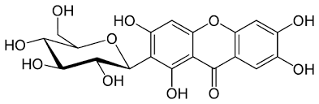
mangiferin

Xanthones commonly are divided into 5 groups: xanthones in the strict sense, phuranoxanthones, pyrano- and dihydropyranoxanthones, dipyranoxanthones, xantholignoids.
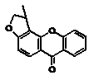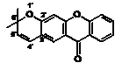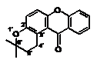
phuranoxanthone linear pyranoxanthone angular pyranoxanthone
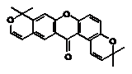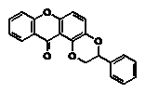
dipyranoxanthone xantholignoid
More than 500 xanthones are currently known to exist in nature, and approximately 50 of them are found in the mangosteen with prenyl substituents. A total of 515 xanthones have been identified in 20 families of higher plants, mainly in Gentianaceae, Clusiaceae (Hypericaceae), Anacardiaceae, Moraceae, Bonnetiaceae and some others.
Mangosteen (Garcinia mangostana) fruit, a typical southeast Asian fruit, is the characteristic dietary source of xanthones. Mangostin is a C-glucosylxanthone that is also found in by-products of mango (Mangifera indica) at high concentration levels.
Mangiferin is accumulated in large amounts in leaves of Mangifera indica. The leaves and roots of Hedysarum spp., Fabaceae contain mangiferin, glucomangiferin and glucoisomangiferin.

Classification
Xanthones isolated from natural sources are classified into six main groups, namely, simple xanthones, xanthone glycosides, prenylated xanthones, xanthonolignoids, bisxanthones, and miscellaneous xanthones.

1. Simple Oxygenated Xanthones
Simple oxygenated xanthones are subdivided according to the degree of oxygenation into non-, mono-, di-, tri-, tetra-, penta-, and hexaoxygenated substances. In these xanthones the substituents are simple hydroxy, methoxy, or methyl groups. About 150 simple oxygenated xanthones have been reported.

1.1. Nonoxygenated Simple Xanthones
The nonoxygenated xanthones, namely, methylxanthones (1-,2-,3-,4-methylxanthone), were reported in crude oils from off-shore Norway. This was the first description of xanthones in fossil organic matter. These xanthones might have been generated as diagenetic products, formed by oxidation of xanthenes in the reservoir, or might have originated by biosynthesis from aromatic precursors.

1.2. Monooxygenated Xanthones
Besides, six monooxygenated xanthones from Swertia, 2-hydroxyxanthone, 4-hydroxyxanthone, and 2-methoxyxanthone have been isolated from four genera, namely, Calophyllum, Kielmeyera, Mesua, and Ochrocarpus.

1.3. Dioxygenated Xanthones
More than fifteen dioxygenated xanthones were reported from plants of the families Clusiaceae and Euphorbiaceae. 1,5-Dihydroxyxanthone, 1,7-dihydroxyxanthone, and 2,6-dihydroxyxanthone are found fairly extensively. Other deoxygenated xanthones such as 1-hydroxy-5-methoxyxanthone, 1-hydroxy-7-methoxyxanthone, 2-hydroxy-1-methoxy-xanthone, 3-hydroxy-2-methoxyxanthone, 3-hydroxy-4-methoxyxanthone, 5-hydroxy-1-methoxyxanthone, and 1,2-methylenedioxyxanthone have been reported from eleven plants genera.

1.4. Trioxygenated Xanthones
Forty-five trioxygenated xanthones have been reported; out of these fifteen were described as new. Among these, only two natural sulfonated xanthones, namely, 1,3-dihydroxy-5-methoxyxanthone-4-sulfonate and 5-O-β-D-glucopyranosyl-1,3-dihydroxy-xanthone-4-sulfonate, are reported from Hypericum sampsonii. These sulfonated xanthones were found to exhibit significant cytotoxicity against cancer cell line. 1,3,5-, 1,5,6-, 1,6,7-, and 2,3,4-trihydroxyxanthone, seventeen methyl ethers, and two methylenedioxy derivatives from nine genera have been reported.

1.5. Tetraoxygenated Xanthones
Among the 53 tetraoxygenated xanthones identified so far, 21 were found to be new natural products. These xanthones were mainly reported from plants of the families Gentianaceae, Clusiaceae, and Polygalaceae. Interestingly, 7-chloro-1,2,3-trihydroxy-6-methoxyxanthone isolated from Polygala vulgaris appeared to be the first chloroxanthone of the family Polygalaceae. This compound exhibited antiproliferative activity against the human intestinal adenocarcinoma cell line. The free hydroxyxanthones are 1,3,5,6-, 1,3,5,7-, and 1,3,6,7-tetrahydroxyxanthone.

1.6. Pentaoxygenated Xanthones
Twenty-seven pentaoxygenated xanthones have been identified. Four partially methylated pentaoxygenated xanthones, namely, 1,8-dihydroxy-2,3,7-trimethoxyxanthone, 5,6-dihydroxy-1,3,7-trimethoxyxanthone, 1,7-dihydroxy-2,3,8-trimethoxyxanthone, 3,8-dihydroxy-1,2,6-trimethoxyxanthone , and 3,7-dihydroxy-1,5,6-trimethoxyxanthone, have been isolated from three plants genera.

1.7. Hexaoxygenated Xanthones
Two hexaoxygenated xanthones, 8-hydroxy-1,2,3,4,6-pentamethoxyxanthone and 1,8-dihydroxy-2,3,4,6-tetramethoxyxanthone, are isolated from two Centaurium species and 3-hydroxy-1,2,5,6,7-pentamethoxyxanthone was isolated from the roots of Polygala japonica. The natural occurrence of pentaoxygenated, hexaoxygenated, and dimeric xanthones has been reviewed by Peres and Nagem.

2. Xanthone Glycosides
Sixty-one naturally occurring glycosylated xanthones, thirty-nine of which are new compounds, have been reported predominantly in the families Gentianaceae and Polygalaceae as C- or O-glycosides. The details of naturally occurring xanthone glycosides have been reviewed and distinction between C-glycosides and O-glycosides has also been made. In C-glycosides, C–C bond links the sugar moiety to the xanthone nucleus and they are resistant to acidic and enzymatic hydrolysis whereas the O-glycosides have typical glycosidic linkage.

2.1. C-Glycosides
C-glycosides are rare; thus, only seven C-glycosides were mentioned in Sultanbawa’s review and 17 in Al-Hazimi’s review. Mangiferin and isomangiferin are the most common C-glycosides. Mangiferin (2,-C-β-D-glucopyranosyl-1,3,6,7-tetrahydroxyxanthone) is of widespread occurrence in angiosperms and ferns and was first isolated from Mangifera indica. An isomer, isomangiferin (4-C-β-D-glucopyranosyl-1,3,6,7-tetrahydroxyxanthone), has been isolated from the aerial parts of Anemarrhena asphodeloides. Homomangiferin (2-C-β-D-glucopyranosyl-3-methoxy-1,6,7-trihydroxyxanthone) has also been isolated from the bark of Mangifera indica. In 1973, another glycoxanthone (2-C-β-D-glucopyranosyl-1,3,5,6-tetrahydroxyxanthone) with an oxidation pattern other than that of mangiferin was found in Canscora decussate. Arisawa and Morita have isolated tetraoxygenated xanthone glycoside 2-C-β-D-glucopyranosyl-5-methoxy-1,3,6-trihydroxyxanthone from Iris florentina.

2.2. O-Glycosides
More than 20 xanthone O-glycosides are known. A few are from natural sources, namely, gentiacauloside from Gentiana acaulis, gentioside from G. lutea, and swertianolin from Swertia japonica. Their natural occurrence is restricted to the family Gentianaceae. The first xanthone O-glycoside, norswertianin-1-O-glucosyl-3-O-glucoside, was isolated from S. perennis. A tetraoxygenated xanthone O-glycoside (3,7,8-trihydroxyxanthone-1-O-β-laminaribioside) was isolated from the fern species. 1-Hydroxy-7-methoxy-3-O-primeverosylxanthone and 1-methoxy-5-hydroxyxanthone-3-O-rutinoside have been isolated from Gentiana species and Canscora decussata.

2.3. Prenylated and Related Xanthones
Among 285 prenylated xanthones, 173 were described as new compounds. The occurrence of prenylated xanthones is restricted to the plant species of the family Guttiferae. The major C₅ unit of the substituents included the commonly found 3-methylbut-2-enyl or isoprenyl group as in isoemericellin and the less frequent 3-hydroxy-3-methylbutyl as in nigrolineaxanthone P and 1,1-dimethylprop-2-enyl as in globuxanthone, respectively. Prenylated xanthones, caloxanthone O and caloxanthone P, were isolated from Calophyllum inophyllum and polyprenylated xanthones and benzophenones from Garcinia oblongifolia.

2.4. Xanthonolignoids
Naturally occurring xanthonolignoids are rare, so only five compounds are known. The first xanthonolignoid was isolated from Kielmeyera species by Castelão Jr. et al. . They also isolated two other xanthonolignoids named Cadensins A and B from Caraipa densiflora. A xanthonolignoid Kielcorin was obtained from Hypericum species. Recently, kielcorin was also isolated from Vismia guaramirangae, Kielmeyera variabilis, and Hypericum canariensis, whereas cadensin C and cadensin D from Vismia guaramirangae and Hypericum canariensis have been reported.

2.5. Bisxanthones
A total of twelve bisxanthones, five from higher plants, one from lichen, and six from fungi, have been reported to date. These include jacarelhyperols A and B, from the aerial parts of Hypericum japonicum and dimeric xanthone, and globulixanthone E, from the roots of Symphonia globulifera. Three C₂-C₂’ dimeric tetrahydroxyxanthones dicerandrols A, B, and C, are also isolated from the fungus Phomopsis longicolla.

2.6. Miscellaneous
Xanthones with substituents other than those mentioned above are included in this group. Xanthofulvin and vinaxanthone were isolated from Penicillium species. A polycyclic substance (xanthopterin) with the ability to inhibit the HSP47 (heat shock protein) gene expression was isolated from the culture broth of a Streptomyces species . Xantholiptin is a potent inhibitor of collagen production induced by treatment with TGF-b in human dermal fibroblasts. Xanthones have been synthesized by different methods. The elements of synthetic methods such as building blocks, Diels-Alder reaction, and heterogeneous catalysts have also been reviewed.

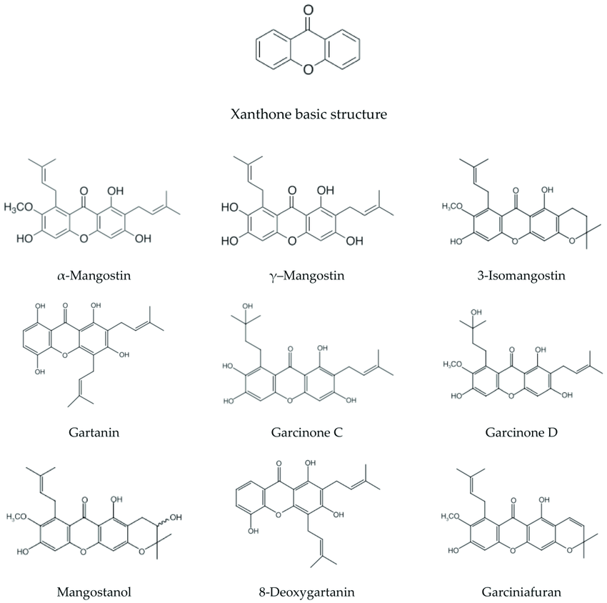

Biosynthesis of Xanthones
Biosynthetically xanthones are of mixed shikimate and acetate origin (Figure 1). Thus, phenylalanine, which is formed from shikimate, loses two carbon atoms from the side-chain and is oxidized to form m-hydroxybenzoic acid. This combines with three units of acetate (via malonate) to give the intermediate. The shikimate-acetate intermediate undergoes ring-closure to give substituted benzophenone, which by an oxidative phenol coupling generates the central ring of the xanthone moiety. This oxidative coupling can take place in two ways depending on the folding of the benzophenone either in the ortho or in the paraposition to the hydroxyl substituent in the potential B-ring to give 1,3,5-trihydroxyxanthone (1) or the 1,3,7-substituted analogue gentisin (2), respectively. Thus, depending on the orientation of the intermediate, two different hydroxylation patterns can be found. Experimental proof for the overall pathway has been obtained from experiments performed using Gentiana lutea.
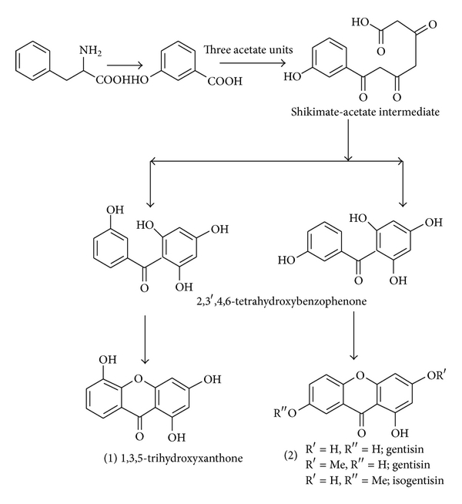
Figure 1
Biosynthetic pathways leading to the xanthones (1) and (2).
When plants were fed ¹⁴C-labeled phenylalanine, the label was recovered solely in the B-ring (Figure 1). Conversely, feeding of ¹⁴C-labeled acetate gave incorporation of the main part in the A-ring. The alternative ring closure to (1) has recently been shown to take place in cultured cells of Centaurium erythraea, where 2,3′,4,6-tetrahydroxybenzophenone is the precursor for 1,3,5-trihydroxyxanthone Furthermore, in these cell cultures, compound (1) is selectively oxidized by a xanthone 6-hydroxylase to 1,3,5,6-tetrahydroxyxanthone. Explored methods for synthesis of simple oxygenated xanthones have been documented by Sousa and Pinto
Physicochemical properties
Xanthones are yellow crystallic substances. They ocuur in plants as aglycones and glycosides. Xanthone aglycones soluble in chloroform, acetone, methanol, ethanol and are insoluble in water. The glycosides are soluble in water, lower alcohols, and insoluble in chloroform.

Extraction of xantones
For xanthone extraction lower alcohols are used; phenolics are fractionated with organic solvents (chloroform, methylene chloride, butanol, ethyl acetate). Separation is carried out by column chromatography or TLC.

Detection
Xanthones develop yellow or yellowish-green fluorescence in UV light. Xanthones have distinct spectral properties, with maxima at 230-245, 250-265, 305-330 and 340-400nm. Like those of fIavonoids, the spectra undergo characteristic bathochromic shifts with alkali, AICl₃ and sodium acetate-boric acid, which vary according to the number and position of the hydroxyl substituents.

Chromatographical analysis

Methods for Isolation and Characterization of Xanthones
Different physicochemical and instrumental methods such as liquid-solid and liquid-liquid extraction, TLC, flash chromatography, column chromatography, IR, ¹H NMR and ¹³C NMR spectroscopy, GLC, HPLC, GC, and LCMS have been widely used for isolation and structural elucidation of xanthones.
Xanthones are commonly separated by TLC on silica gel, using chloroform – acetic acid (4: 1), chloroform-benzene (7: 3) or chloroform - ethyl acetate (varying proportions). They can be detected by their colours in UV light with and without ammonia or by using a general 'phenolic' spray. Mungiferin differs from practically all other xanthones in being water soluble and it separates well on paper.
Plants xanthones are commonly isolated by column chromatography on silica gel using different solvent mixtures with increasing polarity . Xanthone glycosides are usually crystallized from MeOH. They may also be separated and identified using TLC and HPLC by comparison with authentic samples. The structure of xanthones has been established on the basis of UV, IR, MS, and NMR data. Preparative TLC on silica gel using AcOEt, MeOH, and H₂O (21 : 4 : 3) as mobile phase has been used in instances of difficult separation. Frequently used solvents in TLC are on polyamide, MeOH-H₂O (9 : 1) and MeOH-H₂O-AcOH (90 : 5 : 5); on cellulose, HOAc (5–30%); on silica gel, Py-H₂O-AcOEt-MeOH (12 : 10 : 80 : 5) and AcOEt-MeOH-H₂O (21 : 4 : 3) and chromatoplates are viewed in UV light. In certain cases, spraying with 5% KOH in MeOH or 5% aqueous H₂SO₄ has been advantageous. Polyamide columns are frequently applied for the separation of xanthone glycosides. Purification of xanthones on Sephadex LH20 column has also been carried out. Xanthones are also isolated from resin of Garcinia hanburyi and from the fermentation products of an endophytic fungus Phomopsis.
HPLC has been proved as the best technique for separation, identification, and quantification of xanthones. Several HPLC methods have been developed for naturally occurring xanthones using microporous chemically bonded silica gel (Micropak CN column), solvent hexane-chloroform (13 : 7, v/v), isooctane-CHCl₃(3 : 17, v/v), or dioxane-dichloromethane (1 : 9) detected at 254 nm by UV detect. Polar aglycones as well as glycosides of xanthones are also resolved on reversed phase column ( and C₁₈) using acetonitrile-water as mobile phase. High-speed counter current chromatography (HSCCC) and high performance centrifugal partition chromatography (HPCPC) were also used for the separation and isolation of mangiferin and neomangiferin from an extract of Anemarrhena asphodeloides and α-mangostins and γ-mangostins from mangosteen pericarp, respectively.

Ultraviolet Visible Spectroscopy (UV)
Ultraviolet visible spectroscopy technique is useful for locating free hydroxyl groups in xanthones. In particular, the OH group at position 3 is easily detected by addition of NaOAc which results in a bathochromic shift of the 300–330 nm bands with increased intensity. Three or four bands of maximum absorption are always found in the region 220–410 nm and it is noteworthy that all bands show high intensity. Most of the substances show a marked absorption in the 400 nm regions, which accounts for their yellow colour.

Infrared Spectroscopy (IR)
The carbonyl group in xanthones is always easily detectable in IR spectra as a strong band (stretching frequency) in the region of 1657 cm⁻¹ . The presence of a hydroxyl group in the l or 8 position lowers the frequency to about 1650 cm⁻¹by hydrogen bonding. Substituents in the 3 or 6 position of the xanthone nucleus may have a marked effect upon the carbonyl stretching frequency.

Proton Nuclear Magnetic Resonance Spectroscopy (¹H NMR)
1D and 2D-NMR spectra (¹H, ¹³C, DEPT, COSY, TOCSY, HROESY, HSQC, HMBC, and NOESY) have been used for characterization of the xanthones. The ¹H NMR spectrum appears predominantly in the range of 0–12 ppm downfield from the reference signal of TMS. The integral of the signals is proportional to the number of protons present. ¹H NMR gives information about the substitution pattern on each ring. Acetylated derivatives have been utilised in the structure determination of glycosides. The number and relative position of acetyl and methoxy groups can be determined by observing the shift for the position of absorption for the aromatic protons which occurs upon replacing methoxy group by an acetyl group. Signals between δ 2.40–2.50 are indicative of acetylation at peri-position to the carbonyl group (1 or 8 position) since for other positions the acetyl signals fall between δ 2.30 and 2.35. In nonacetylated xanthones the presence of hydrogen bonded OH at δ 12-13 also confirms hydroxyl substitution at 1 or 8. But when these positions are unsubstituted, then absorption for the aromatic protons appears at δ 7.70–8.05 . Tetraoxygenated xanthones, namely, 1,3,7,8- and 1,3,5,8-, showed two meta- and two ortho-coupled protons in the ¹H NMR spectrum. They can also be distinguished by the fact that the presence for the ortho-coupled proton in the 1,3,7,8- system appears at lower field [83] than that for 1,3,5,8- (bellidifolin) system. The signals of -O-acetyl methyl protons of 8-C-glucosyl flavone acetate are found at higher field than those of corresponding 6-C-glucosyl flavone acetate. In a similar manner, 2-C and 4-C isomeric glycosyl xanthones can be distinguished.

Carbon Nuclear Magnetic Resonance Spectroscopy (¹³C NMR)
The number of signals in the ¹³C NMR spectrum indicates the number of different types of C atoms. It gives the information about the total number of the C atoms present in the molecule. It is particularly diagnostic for determining the sugar linkage in di- or polysaccharides; the signal of the carbon carrying the primary alcohols appears at δ 62 in glucose. This signal is shifted to 67 in disaccharides possessing a 1–6 linkage. The chemical shift for carbonyl carbon is 184.5 when positions 1 and 8 are substituted by hydroxyl groups. But when one of these positions is occupied either by a methoxy or a sugar moiety, the carbonyl signal is shifted upfield by about 4 ppm. If both positions are occupied by a methoxy group or sugar moieties, the upfield shift is about 10 ppm. When methoxy groups are located in position 1 or 8, the corresponding absorption appears at δ60-61, whereas they appear at about 56 when the methoxy group is located in the remaining positions on xanthone nucleus.

Mass Spectrometry (MS)
Mass spectrometry is also a useful tool in the structure elucidation of xanthone glycosides. Prox established the fragmentation pattern of mangiferin and related C-glycosides. Aritomi and Kawasaki obtained satisfactory results using peracetylated derivatives of the same and analogous compounds. In mass spectrum of O-glycosides, no discernible molecular ion peak can be observed, but an important fragment ion peak due to the aglycone moiety appears, followed by further fragmentation. Significant fragment ions from the loss of OH, H₂O, and CHO are typical for xanthones and related compounds with a methoxy substituent peri to the carbonyl group.

Biological activity of xantones
Xanthones consist of γ-pyrone like flavonoids and exhibit a wide range of biological activities (antioxidative, cardiovascular protective, antimycobacterial). Mangostin inhibits the oxidative modification of human low density lipoprotein. Xanthones possess potent antiviral action. Mangiferin stimulates central nervous system, in large doses acts as cardiotonic and diuretic, anti-inflammatory and antibacterial agent.

Biological Activities of Xanthones
Hepatoprotective, anticarcinogenic, antileprosy, antimalarial, antioxidant, anticholinergic, mutagenicity, radioprotective, immunomodulatory, antibone resorption, antiparasitic, neuraminidase inhibitory, anticomplement, antibacterial, antifungal, algicidal, anti-HIV, cardioprotective, antitumoral, antidiabetes, antihyperlipidemic, antiatherogenic, anti-inflammatory, antiulcer, antidiabetic, hypolipidemic, analgesic, antiasthmatic, antihistaminic, antiamoebic, diuretic, antidiarrheal, larvicidal, and ovicidal activities have been reported for natural occurring xanthones.

Plants belonging to the family Gentianaceae are best known for their bitter taste due to the presence of xanthones and are used in traditional remedies against loss of appetite and fever and are still included in many “tonic” formulations. Some specific activities have been reported for xanthones and iridoids from Gentianaceae. Xanthones (especially mangiferin) are reported to give CNS stimulation and have anti-inflammatory activity. For bellidifolin and swerchirin, a strong hypoglycemic activity has been reported. A crude extract of Swertia has been reported to display insect repellent activity. The extracts of most of the Swertia species show mutagenic activity. An extract from S. paniculata is used in the Indian System of Medicine as a bitter tonic and in the treatment of some mental disorders. S. hookeri extract is used in the treatment of microbial infections and as a mood elevator. Swertifrancheside isolated from S. franchetiana was found to be potent inhibitor of the DNA polymerase activity of human immunodeficiency virus-1 reverse transcriptase. Naturally occurring xanthones have emerged as an important class of organic compounds in view of their remarkable pharmacological and other biological activities. It has now been observed that a number of plant products which are in regular use as chemotherapeutic agents contain xanthones as active constituents. Mangiferin was the first xanthone to be investigated pharmacologically and has been found to exhibit a broad spectrum of biological activities. It shows monoamine oxidase inhibition, cardiotonic, convulsant, and choleretic activities. Pronounced anti-inflammatory activity has also been observed for mangiferin. Oral and topical compounds containing mangiferin are useful for the treatment of diseases caused by herpes virus. Mangiferin has been found to protect the liver of the rats from high altitude hypoxia. On the other hand, Ghosal and Chaudhuri have observed the opposite CNS depressant effect for xanthone-O-glycosides in mice and rats. The antimalarial drug AYUSH-64 contains S. chirata as one of the ingredients. Xanthones from S. chirata are reported to produce CNS depression. The total extract of S. chirata showed significant antifeedant activity against Jute semilooper . Norswertianolin, an O-glycoside, has been reported to produce antitubercular activity. The O-glycosides of S. purpurascens are known to produce CNS depression in albino rats and mice. Xanthones of Mammea americana exhibited inhibitory activity against sarcoma 180 tumor cell. 1,8-Dihydroxy-3,5-dimethoxyxanthone (swerchirin), isolated from the hexane fraction from Swertia chirayita, has a very significant blood sugar lowering effect in fasted, fed, glucose loaded, and tolbutamide pretreated albino rats. The for 40% glycaemia lowering in CF male albino rats was 23.1 mg/kg when orally administered. Swertia species have also been investigated for the presence of essential elements. Xanthones have been reported to display hepatoprotective, antimicrobial, anticarcinogenic, antileprosy, antioxidant, anticholinergic, mutagenicity, and radioprotective effect, immunomodulatory effect, antibone resorption, and antiparasitic effects, neuraminidase inhibitory, antimalarial, anticomplement, antifungal and algicidal, and anti-HIV activity, and cardioprotective, antitumoral, antibacterial, antidiabetes, antihyperlipidemic, antiatherogenic, immunomodulator, anti-inflammatory, antiulcer, antiviral, antifungal, antidiabetic, hypolipidemic, analgesic, antiasthmatic, antihistaminic, antiamoebic, diuretic, antidiarrheal, larvicidal, ovicidal, antiprotozoal, antileptospiral, anti-TMV, and anticancer activities. Xanthones from S. mussotii were evaluated for their anti-hepatitis B virus activity on HepG 2.2.15 cells line; they exhibited significant activity inhibiting hepatitis B virus DNA replication with IC₅₀ values from 0.01 mM to 0.13 mM.

